**Chapter 5 - Nervous System**

**All Lectures Uploaded on YouTube:**

[**https://tinyurl.com/fkm10-biology**](https://tinyurl.com/fkm10-biology)

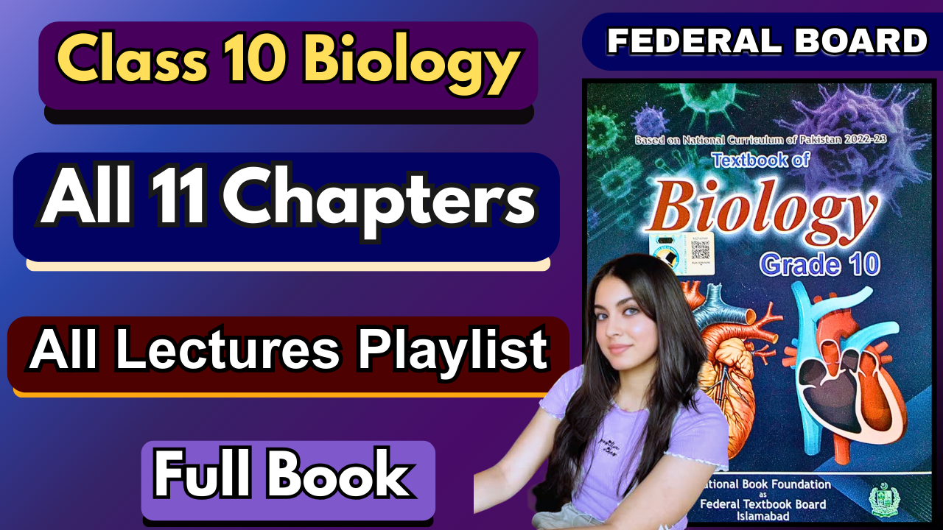

**MCQs**

1. C
2. A
3. A
4. B
5. C
6. B
7. A
8. C
9. C
10. C
11. D
12. A
13. D
14. A

**Short Questions**

**1. What is the nervous system?**

The nervous system is a complex network of nerves and cells that carry messages to and from the brain and spinal cord to various parts of the body. It controls and coordinates all body functions and allows us to react to changes in our environment.

**2. What is the role of the nervous system?**

The nervous system's primary role is to coordinate voluntary and involuntary actions and transmit signals between different parts of the body. It allows us to perceive, understand, and respond to both internal and external stimuli.

**3. Differentiate between the central nervous system (CNS) and the peripheral nervous system (PNS).**

The **CNS** consists of the brain and spinal cord, acting as the main processing centre. The **PNS** is made up of all the nerves extending from the CNS to the rest of the body. It transmits sensory information to the CNS and carries motor commands from the CNS to the muscles and glands.

**4. Name the parts of the human brain.**

The main parts of the human brain include the **cerebrum**, **cerebellum**, and **brainstem**. The cerebrum is the largest part, responsible for higher-level functions. The cerebellum coordinates movement and balance. The brainstem controls basic life-sustaining functions.

**5. Write two functions of the cerebellum.**

The cerebellum is crucial for maintaining **posture and balance** by integrating sensory input and coordinating muscle movements. It also plays a key role in **coordinating voluntary movements**, allowing for smooth, precise, and well-timed actions.

**6. How are the brain and spinal cord protected?**

The brain is protected by the skull, while the spinal cord is protected by the vertebral column (backbone). Both are also cushioned and protected by three layers of membranes called the **meninges** and by cerebrospinal fluid, which acts as a shock absorber.

**7. Describe the peripheral nervous system.**

The peripheral nervous system (PNS) is the part of the nervous system that is not the brain and spinal cord. It consists of all the nerves that branch out from the CNS, carrying sensory information from the body to the CNS and motor commands from the CNS to the muscles, organs, and glands.

**8. What are the types of neurons? What are their functions?**

There are three main types of neurons:

* + **Sensory neurons:** Carry signals from receptors in the body towards the CNS.
  + **Motor neurons:** Carry signals from the CNS to muscles or glands (effectors).
  + **Interneurons:** Connect sensory and motor neurons within the CNS, acting as relays.

**9. Define stimulus with examples.**

A **stimulus** is any detectable change in the internal or external environment that can provoke a response from an organism. Examples include light (stimulus for sight), sound (stimulus for hearing), heat (stimulus for a reflex), or a chemical change in the blood (stimulus for hormone release).

**10. Define and sketch a synapse.**

A **synapse** is the small gap between two neurons where nerve impulses are chemically transmitted. When an impulse reaches the end of the first neuron, neurotransmitters are released into this gap to carry the signal to the next neuron.

**11. How does an impulse cross a synapse?**

When a nerve impulse reaches the end of a neuron (the presynaptic terminal), it triggers the release of neurotransmitter molecules into the synapse. These molecules diffuse across the gap and bind to specific receptors on the next neuron (the postsynaptic neuron), which then generates a new impulse.

**12. What action or change do neurotransmitters transmit to the target cell?**

Neurotransmitters transmit a chemical signal that can either **excite** or **inhibit** the target cell. An excitatory signal makes the target cell more likely to start an impulse, while an inhibitory signal makes it less likely to start. This is how messages are passed between neurons.

**13. What happens to neurotransmitters after they deliver their message?**

After binding to receptors and delivering their message, neurotransmitters are quickly removed from the synapse. This is done either by being broken down by enzymes or by being reabsorbed by the presynaptic neuron through a process called reuptake. This prevents continuous signalling and allows the synapse to reset for the next impulse.

**14. How many different types of neurotransmitters are there?**

There are many different types of neurotransmitters, with estimates ranging from dozens to over a hundred. Some of the most well-known include acetylcholine, dopamine, serotonin, and norepinephrine. Each type has specific functions and pathways in the nervous system.

**15. What is a reflex action?**

A **reflex action** is an involuntary, rapid, and automatic response to a stimulus. It is a quick response that doesn't require conscious thought, often mediated by a reflex arc involving the spinal cord. An example is pulling your hand away from a hot stove.

**16. Name the endocrine glands of man.**

The main endocrine glands include the **pituitary gland**, **thyroid gland**, **parathyroid glands**, **adrenal glands**, **pancreas**, **ovaries** (in females), and **testes** (in males).

**17. Name the hormones secreted by each of the endocrine glands.**

* + **Pituitary gland:** Growth hormone, thyroid-stimulating hormone (TSH).
  + **Thyroid gland:** Thyroxine.
  + **Adrenal glands:** Adrenaline, cortisol.
  + **Pancreas:** Insulin, glucagon.
  + **Ovaries:** Estrogen, progesterone.
  + **Testes:** Testosterone.

**18. Differentiate between:**

* + **Cerebrum and Cerebellum:** The **cerebrum** is the largest part of the brain, responsible for conscious thought, memory, and voluntary action. The **cerebellum** is located at the back of the brain and coordinates movement, posture, and balance.
  + **Sensory and Motor Neuron:** A **sensory neuron** transmits impulses from receptors to the central nervous system. A **motor neuron** carries impulses from the central nervous system to muscles or glands to initiate a response.
  + **Voluntary and Involuntary Action:** A **voluntary action** is a deliberate, conscious act, like writing or speaking. An **involuntary action** is a spontaneous, automatic response, such as a reflex or the beating of the heart.
  + **Nerve impulse and Hormonal transmission:** A **nerve impulse** is an electrical signal that travels rapidly along neurons. **Hormonal transmission** involves chemical messengers (hormones) travelling through the bloodstream, a slower but longer-lasting process.
  + **Endocrine and Exocrine Glands:** **Endocrine glands** secrete hormones directly into the bloodstream (e.g., thyroid). **Exocrine glands** release their secretions through ducts to a specific location (e.g., salivary glands).

## **Extensive Answer Questions**

**1. Describe the nervous system and its role in humans.**

The nervous system is the body's main control and communication network. It is composed of the **central nervous system (CNS)**, which includes the brain and spinal cord, and the **peripheral nervous system (PNS)**, which consists of all the nerves outside the CNS. The brain processes information from the environment and the body, while the spinal cord acts as a relay for signals. The nervous system's role is to coordinate all voluntary and involuntary actions, from thinking and moving to breathing and digesting. It receives sensory information, integrates it, and sends out motor commands, allowing the body to respond to stimuli and maintain homeostasis.

**2. Draw a vertical section of the human brain and label it. Write the functions of each part.**

* + **Cerebellum:** Coordinates balance, posture, and smooth, precise motor movements.
  + **Cerebrum:** The largest part; responsible for conscious thought, memory, language, and voluntary movements.
  + **Brainstem (midbrain, pons, medulla oblongata):** Connects the cerebrum and cerebellum to the spinal cord; controls vital involuntary functions like breathing, heart rate, and blood pressure.
  + **Hypothalamus:** Regulates body temperature, hunger, thirst, and links the nervous and endocrine systems.
  + **Thalamus:** A relay station for sensory information travelling to the cerebral cortex.

**3. Draw, label cross-section of the human spinal cord and write its structure and function.**

The spinal cord is a long, thin, tubular bundle of nervous tissue that extends from the brainstem. In a cross-section, it shows a central grey matter shaped like a butterfly or 'H' and an outer white matter. The **grey matter** contains the cell bodies of neurons and interneurons, while the **white matter** consists of myelinated axons that transmit signals. The spinal cord's main functions are to: 1) act as a relay for sensory information from the body to the brain and for motor commands from the brain to the body, and 2) mediate reflex actions independently of the brain, allowing for rapid, automatic responses.

**4. Outline the types of neurons with diagrams.**

* + **Motor neurons:** These neurons have a cell body at one end with a long axon that extends to a muscle or gland. They carry signals from the CNS to the body's effectors, causing a response.
  + **Sensory neurons:** These neurons have a single, long axon that branches into two parts: one extending to the sensory receptor (e.g., in the skin) and the other extending to the spinal cord. They carry signals from the body's receptors toward the CNS.
  + **Interneurons:** These neurons are located entirely within the CNS. They have a complex network of dendrites and axons that form connections with other neurons. Their primary function is to serve as a relay station, integrating information between sensory and motor neurons.

**5. Explain that nerve impulses are electrical signals that travel across the neuron.**

Nerve impulses, are electrical signals that are propagated along the length of a neuron's axon. This process is driven by the movement of ions (primarily sodium and potassium) across the neuron's membrane. When a stimulus reaches a certain threshold, a rapid influx of sodium ions into the neuron causes a depolarisation, creating a positive charge that travels down the axon. This is followed by an outflow of potassium ions to restore the negative charge. The impulse travels quickly, ensuring rapid communication throughout the body.

**6. What are neurotransmitters?**

Neurotransmitters are chemical messengers that transmit a signal from one neuron to another across a synapse. They are stored in small sacs called vesicles at the end of an axon. When a nerve impulse arrives, these vesicles fuse with the cell membrane and release the neurotransmitters into the synaptic cleft. The molecules then bind to receptors on the postsynaptic neuron, initiating an electrical signal in that neuron. This chemical transmission allows for precise and regulated communication between neurons and is essential for all nervous system functions.

**7. Explain reflex action with a diagram.**

A reflex action is an automatic, involuntary response to a stimulus that does not involve conscious thought. This rapid response is mediated by a neural pathway called the **reflex arc**. The process begins when a **receptor** detects a stimulus. A **sensory neuron** then carries the signal from the receptor to the spinal cord. Within the spinal cord, an **interneuron** (in some cases, the sensory and motor neurons connect directly) receives the signal and relays it to a **motor neuron**. The motor neuron then sends a command to an **effector** (a muscle or gland), which carries out the response, such as pulling a hand away from a hot object. The entire process happens very quickly to protect the body from harm.

**8. Identify the major endocrine hormones with their functions.**

* + **Insulin (from the pancreas):** Lowers blood sugar by promoting glucose uptake by cells.
  + **Glucagon (from the pancreas):** Raises blood sugar by stimulating the liver to release stored glucose.
  + **Adrenaline/Epinephrine (from the adrenal glands):** The "fight-or-flight" hormone; increases heart rate, blood pressure, and energy for a rapid response to stress.
  + **Thyroxine (from the thyroid gland):** Regulates metabolism and growth.
  + **Growth hormone (from the pituitary gland):** Promotes growth and cell reproduction.
  + **Cortisol (from the adrenal glands):** A stress hormone that regulates metabolism and suppresses inflammation.
  + **Estrogen (from the ovaries):** Regulates female reproductive system and secondary sexual characteristics.
  + **Testosterone (from the testes):** Regulates male reproductive system and secondary sexual characteristics.

